Module-3 Assignment
Project Title: E-Commerce Customer Churn Analysis
Results

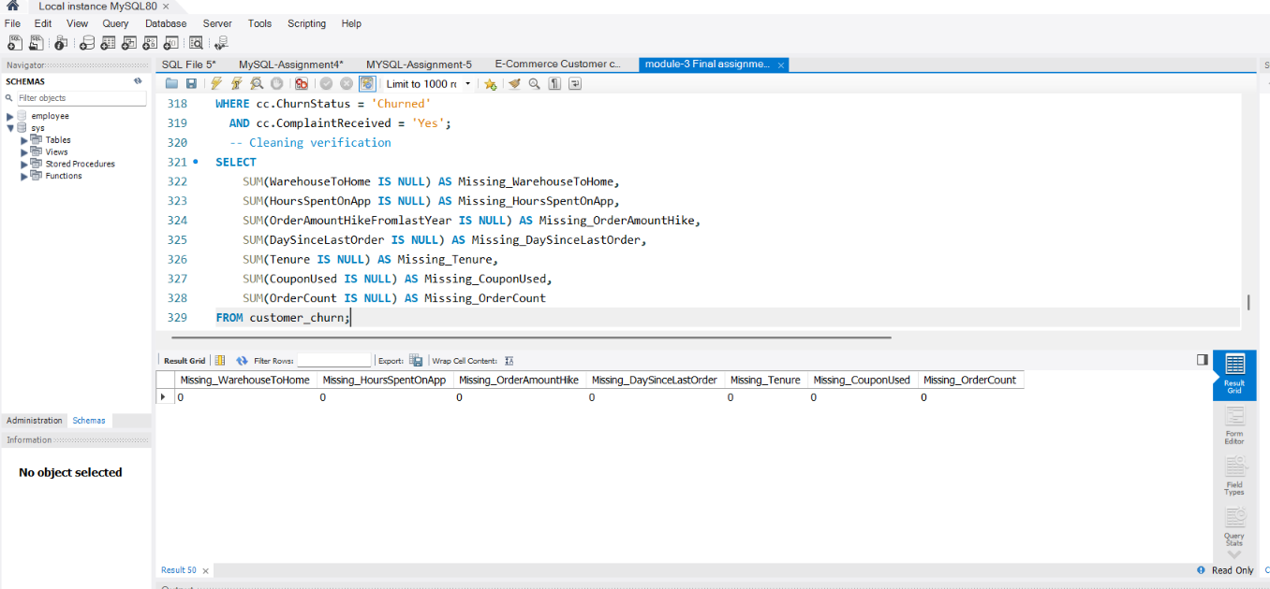
- Data Cleaning

- 2.Data Transformation
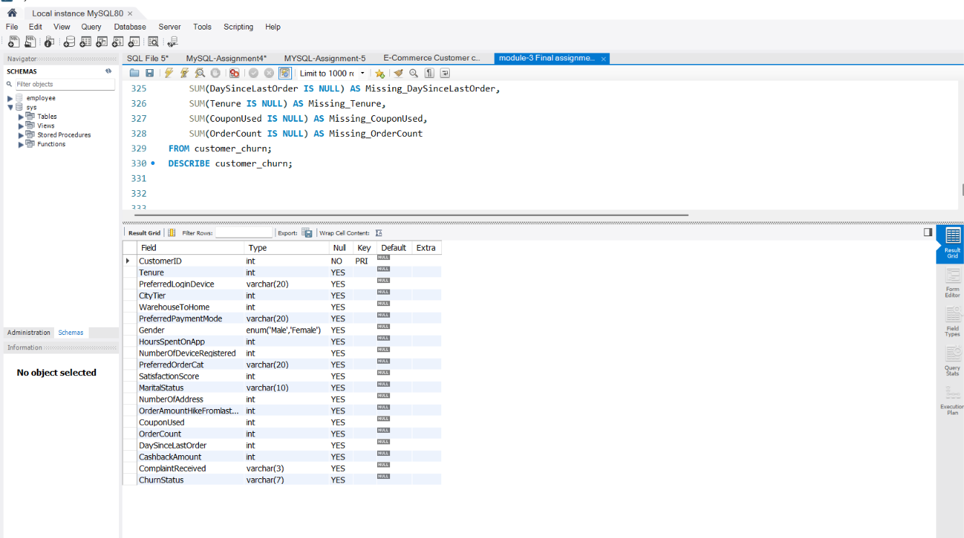

- Return Table
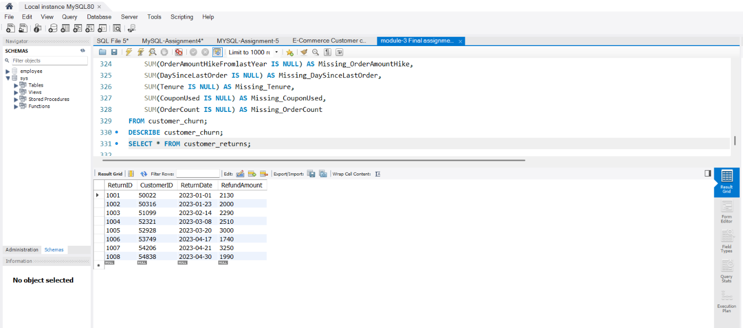

- Final Join
